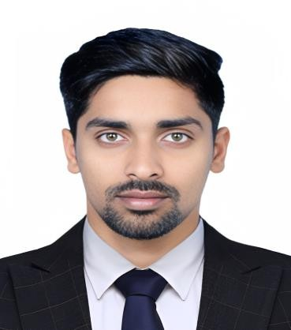

Profile

Name : Mr. Manmohan Sahu Designation : Guest Lecturer
Job Place : Govt. Chandulal Chandrakar Arts and Science College, Patan,
Dist- Durg(C.G.)
Father’s Name : Mr. Ramprasad Sahu
Mother’s Name : Mrs. Pushpa Sahu DOB : 04/02/1999
Address : Ward No. 54,Seepat Road, Bilaspur , Distt.-Bilaspur Pincode-495006
Nationality : Indian
Mo.No : 9993322739
E-mail : manmohan1739@gmail.com

Academic Qualification :

Examination | University/Board | Name Of Institute | Subject | Passing Year | Percentage
10th | CGBSE | MGVM lORMI | Hindi,English,Maths,  Science,Sanskrit,Social Science | 2014 | 64.33
12th | CGBSE | MGVM lORMI | Hindi,English,Pol.Sci,  History,Geography | 2016 | 77.4
BA Hon's English | GGU | Guru Ghasidas Vishwavidyalaya Bilaspur CG | Hindi,English,Pol.Sci, History,Eng.Lit. | 2019 | 65.66
MA  English | GGU | Guru Ghasidas Vishwavidyalaya Bilaspur CG | English Literature | 2021 | 75
NET/JRF | NTA UGC NET | UGC | English | 2022 | QUALIFIED
GATE | IIT Kharagpur | IIT Kharagpur | English | 2022 | QUALIFIED
B.ed | KUK | KUK | Teaching | 2023 | 63.26
CGTET | CGVYAPAM | CGVYAPAM | Teaching | 2022 | QUALIFIED

Areas of specialization:
- English Literature – British Poetry and Drama, American Literature

Academic Experience:
- Worked as a Guest Lecturer in Govt. Chandulal Chandrakar Arts and Science College, Patan, Dist- Durg (C.G.) from 19/08/2022 to till now.

Details of Seminar/Conference/Workshop: attended or presented:

S.  No. | Title of workshop/Conference/  Seminar/Webinar | Organizer & Venue | Date | Participated
1 | Skill Development Workshop on "Communication & Soft Skills" | Skill Development Cell & Dept Of English & Foreign Languages ,GGU | 6-8/02/2017 | Participated
2 | A Workshop on "Communication Skills& Personality Development" | Skill Development Cell & Dept Of English & Foreign Languages ,GGU | 12-13/11/18 | Participated
3 | 2-Day International Webinar on  Delving Deep: Language Skills &Under-Current Personality Development | Govt. Engineering College, Daman | 22-23/04-21 | Participated

Declaration
I hereby declare that all above information given by me is true and correct to the best of my Knowledge.

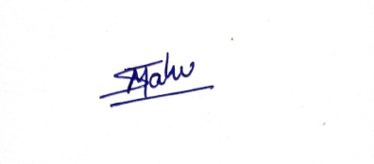

Place: Patan Manmohan Sahu
Date: 24-08-2023

